IP/ICMP Attacks Lab

Tasks 1: IP Fragmentation

Task 1.a: Conducting IP Fragmentation
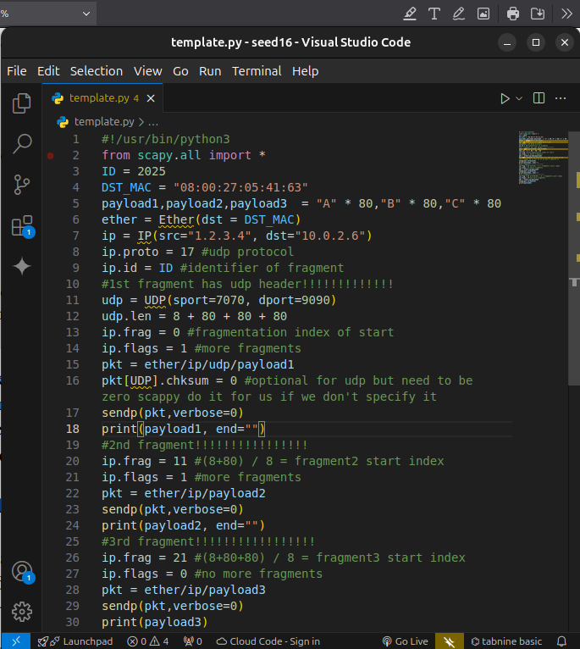
.
here our code we use 3 fragments only the first has the header udp to specify the length that it should wait for. The id of the fragment is used to identify packet to be reassembled later on.
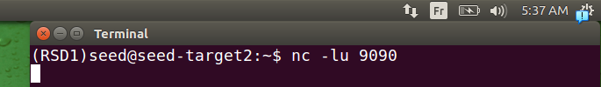
.here we start with netcat to listen for udp packets in port 9090
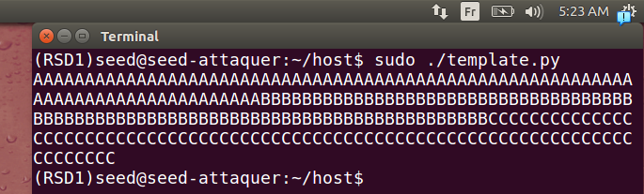
.here we seend them coorrectly
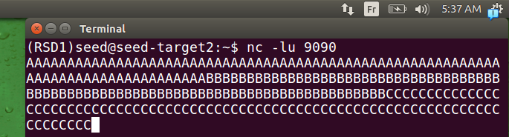
.here we received them correctly
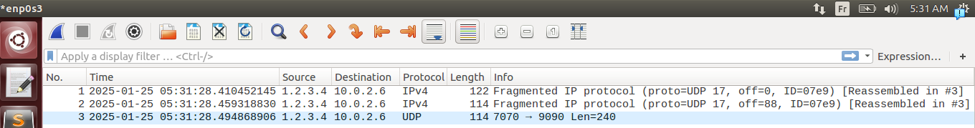
.here we can see when reassemble packet is applicated the udp header appears in wireshark only at the end, like ther’s not order for him. Note that what appears to be true here doesn’t mean it’s in the machine, we will discuss it later.
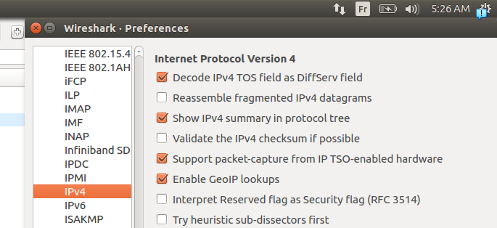
.here we desable It to show them in order
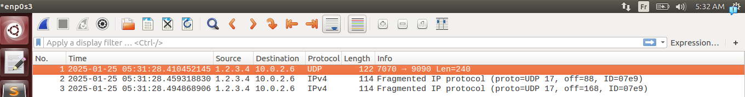
.here they are in order and doesn’t care about reassemblement.

Task 1.b: IP Fragments with Overlapping Contents
Here it’s normal case:
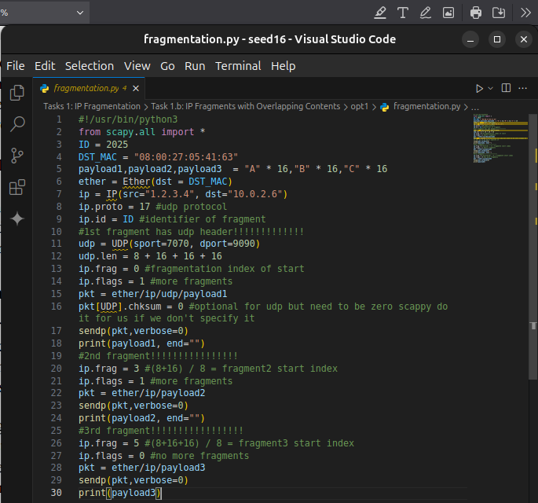
If we write in normal case but for 16 for each char.
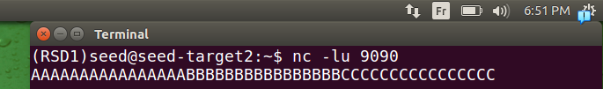
.result is corectly received

here we put k = 8 note that later we will mention when k not divisible by 8 what will deffer
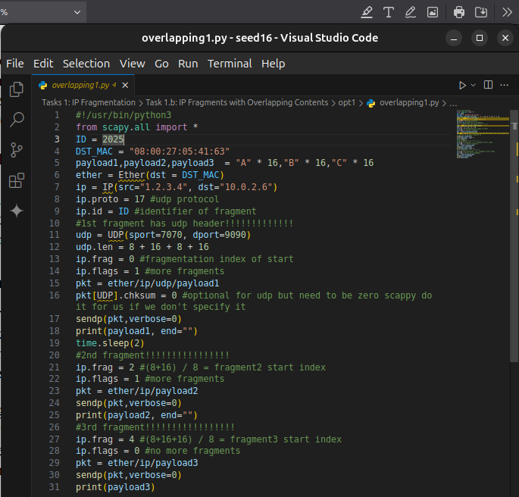
.if we send the fragment1 befor fragment2 with overlapping 8 bytes
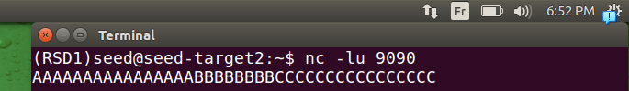
.we got that early deliverred packets for offset cant’t overwrite existing one with law offset
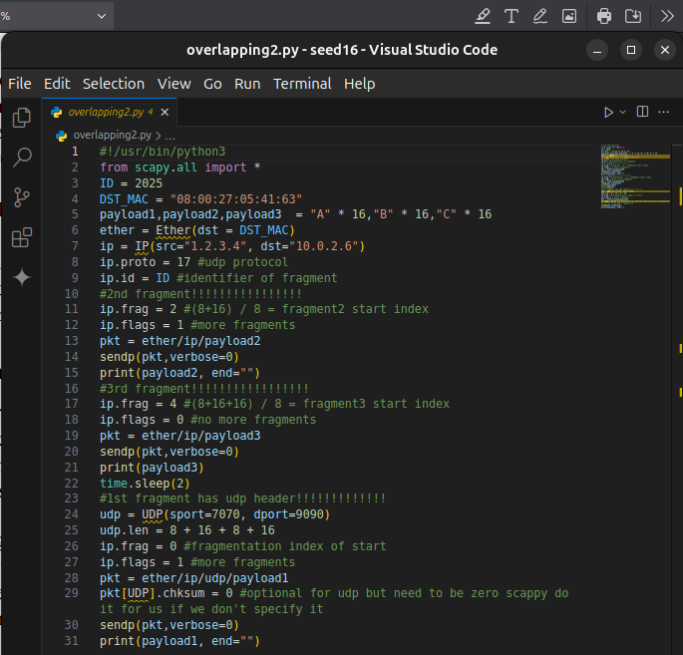
.sape goes if we send fragment2 before fragment 1
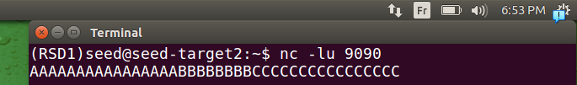
.result is the same as the last one
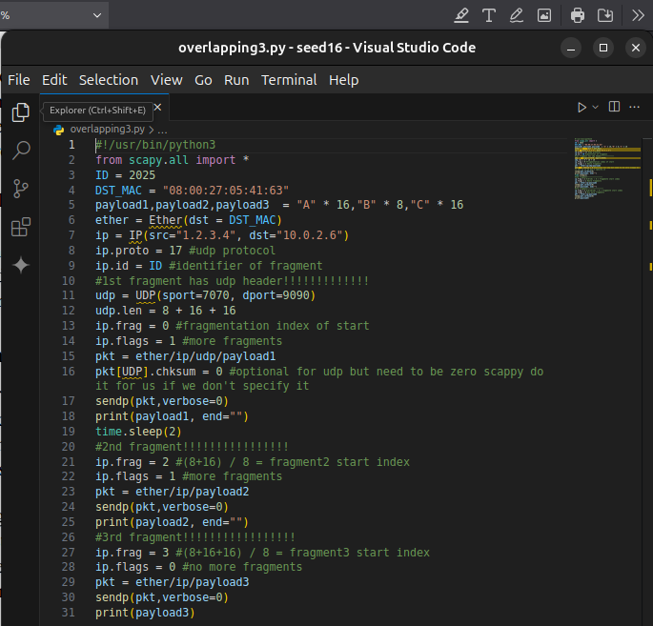
.here we put B into A (overlapping)
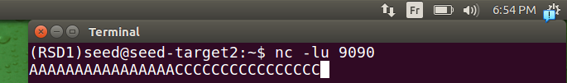
.it prefers the packet A
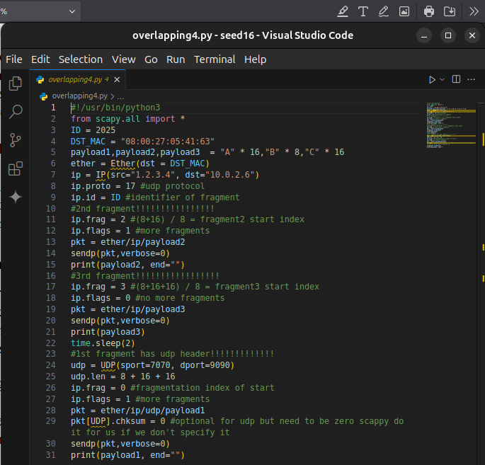
same goes if we start with second fragment
same result
note that if fragment not with length divisible by 8 the remaining not divisible by 8 will not be considered.

Task 1.c: Sending a Super-Large Packet
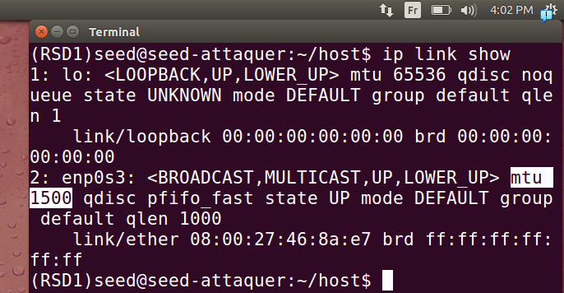
.here we can see MTU = 1500 it’s the max length of packet we can send
.
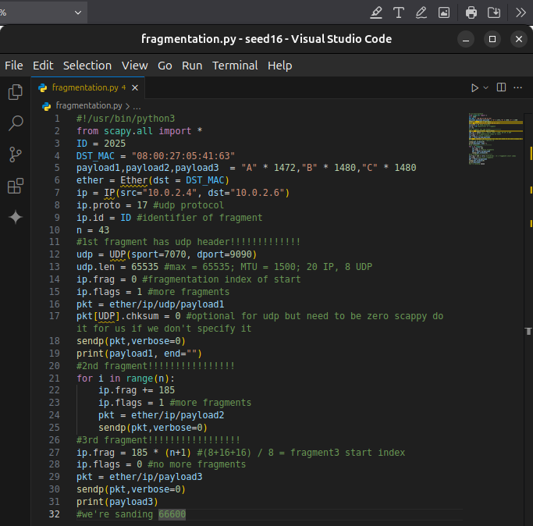
.here we put length 65535 = 2¹⁶ max length of the full packet and we send knowing mtu is 1500 so we escape it, and last fragment will get out of range.
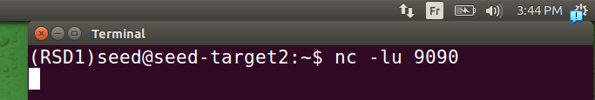
.here we lunch a listenning server on port 9090
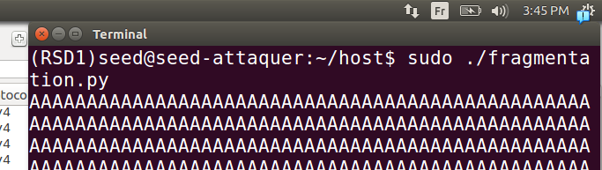
.in the attaque machine we lunch it
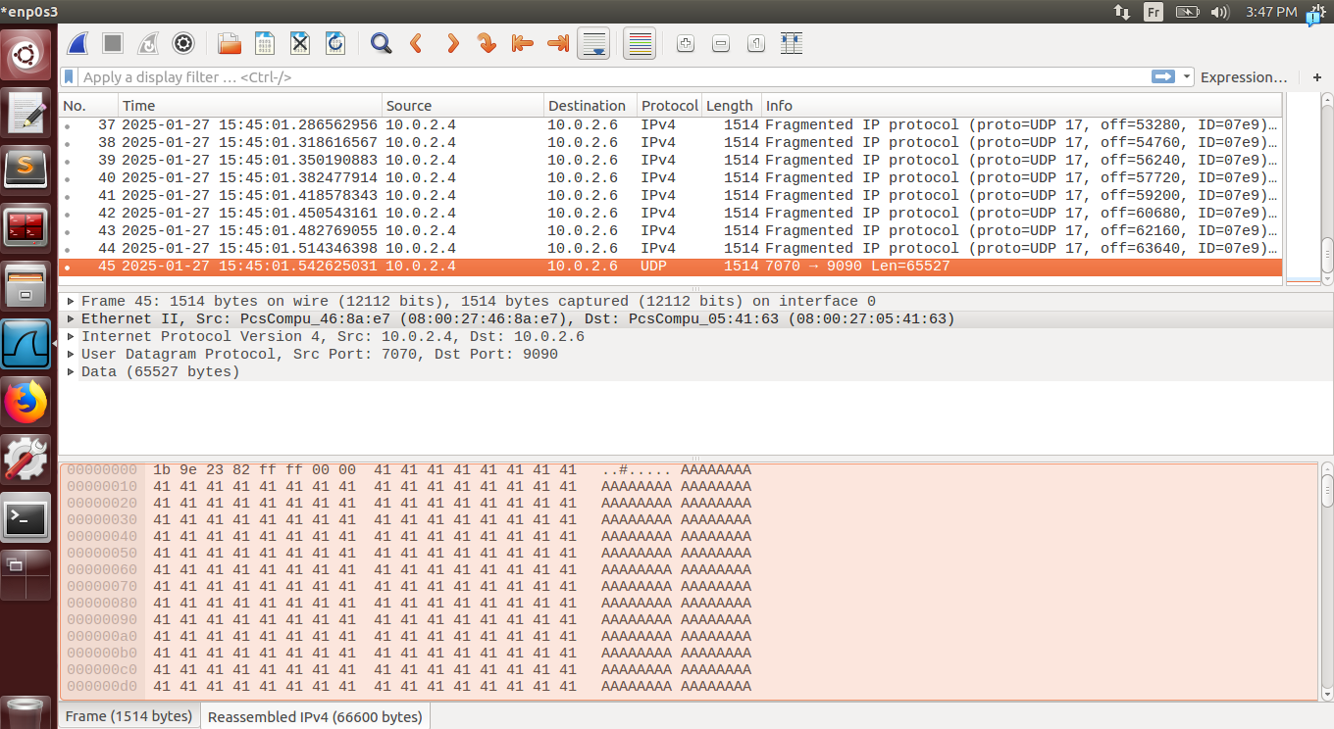
.we can see that the total packet sent is 66600>65535
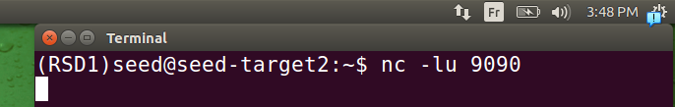
.the victim machine doesn’t accept it .
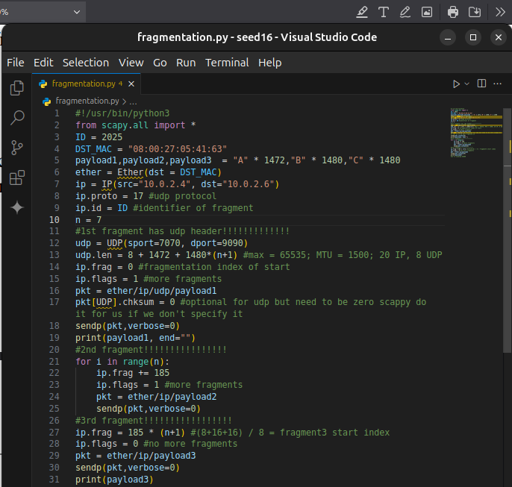
We have remarqued a case that nc has it’s limit If we send like 13320 < 65535 it will show only a part of it and will block after that
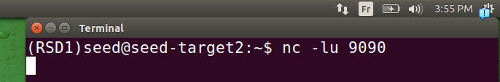
.we lunch the victim in listenning mode
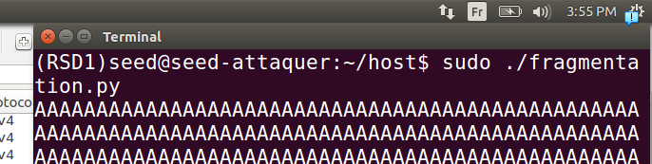
.we lunch from the attaquer
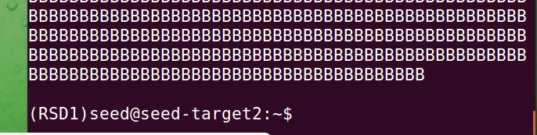
.here we can see that it didn’t affich the all of the packet and get blocked

Task 1.d: Sending Incomplete IP Packet
.
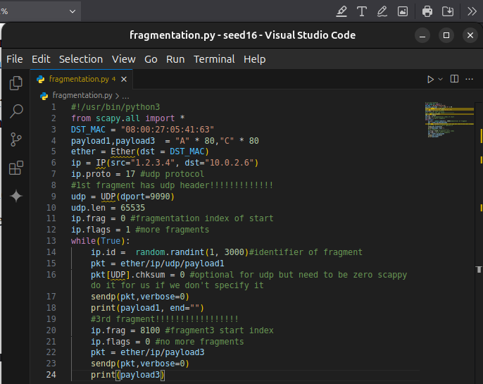
this code do a while for incomplete packets with big difference in offset
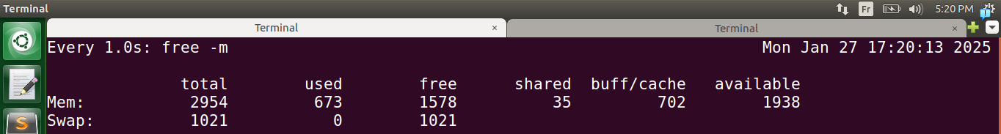
.here we watch -n 1 free -m to view memory usage in real time
.we lance the server side
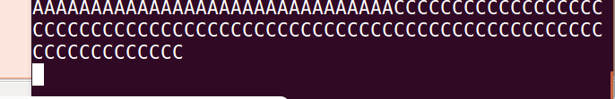
.here we lunch the script from the attaquer machine
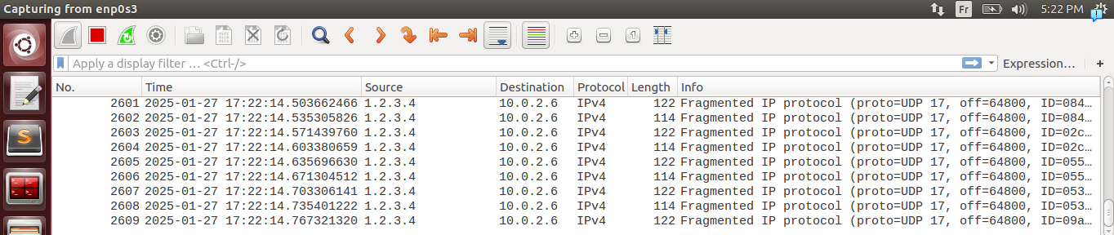
.we sent a lot of packets doen’t matter if you use C or python here beacause 30secondes is used it’s enough to make a lot of packets
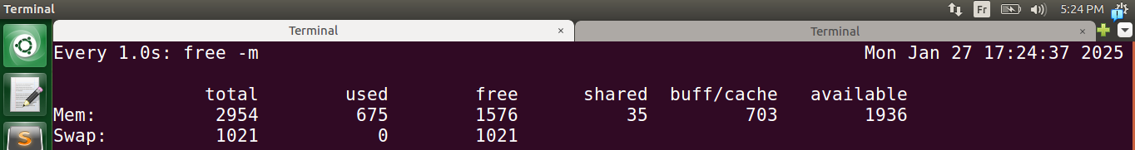
.it doesn’t seem to affect much this DOS has failed and will explain in the next session the mecanismes that stopped us from successing in theses attques.

Mecanisme used by linux to secure:
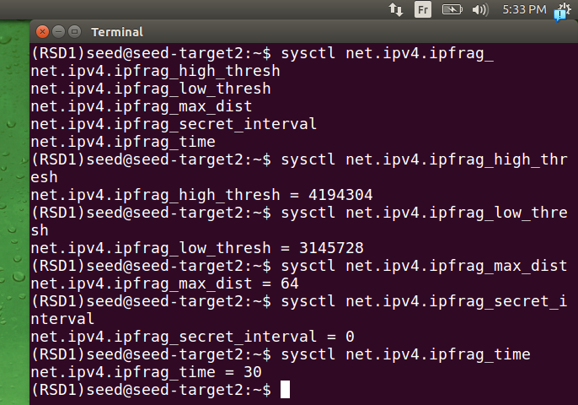
.

net.ipv4.ipfrag_high_thresh
Define a maximum memory usage this helped us in task 1.d so DOS attaque doesn’t work even if you use C and not python this mecanisme define a max if it’s reached he drops old fragments incompleted, here it’s 4MB

net.ipv4.ipfrag_low_thresh
Define a minimum memory usage this when he starts droping when max reached he will drop until he reach this point, here we got 3MB, this used with the high to prevent DOS attacks task1.d

net.ipv4.ipfrag_max_dist
This one define the max distance between offset of first fragment of a packet and the last offset, here we got 64KB, this one can help manage max length of a packet when reassembled, it’s used in task1.c

net.ipv4.ipfrag_secret_interval
Here it’s value 0 it’s disabled.

net.ipv4.ipfrag_time
Here it’s used to discard incomplete packets that didn’t fully arrive, here the value is 30secondes, this can help in DOS attaques to prevent it like in task1.d

Task 2: ICMP Redirect Attack

For a machine in LAN existing:
.
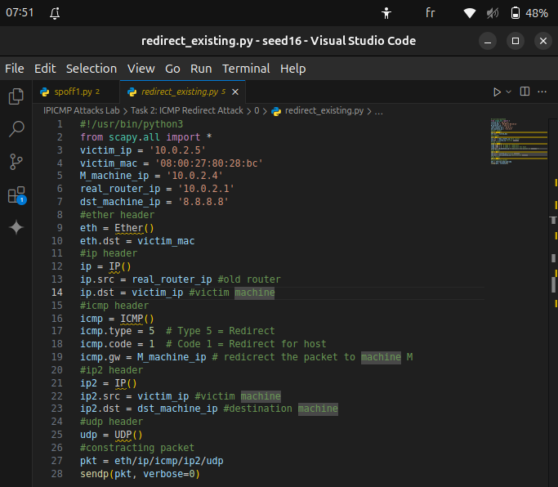
.for this script we specify type = 5 for redirection, code = 1 for host redirection because there’s also code = 0 for network redirection it refers like the network you try to access and the other is the host you want to reach, here we need to encapsulate DNS resolver packet(we just simulate it)
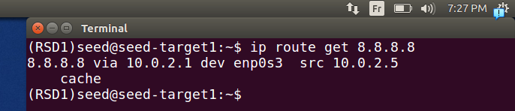
.here the original route was to go out from default gatway created by virtual box
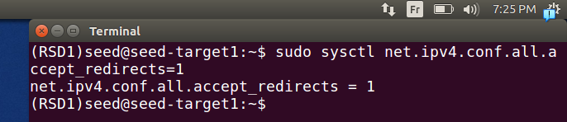
.here we activate this to accepte the icmp redirection messages because by default it’s desactivated in machines so it doesn’t happen such attacks as this.
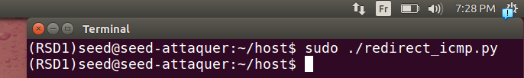
.here we lunch our script from attaquer machine
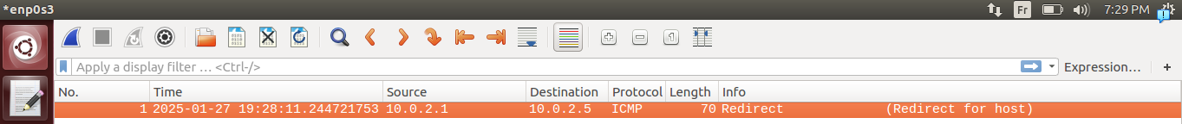
.we can see the message in Wireshark it goes smothly as we wanted
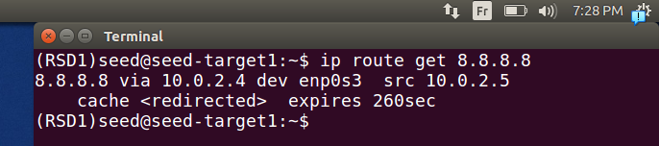
.if we go to the victim machine and run again the command we can that it changed correctly
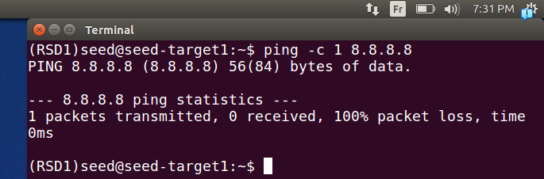
.if we ping that address redirectionned, we can see that it pings but it can’t response yet
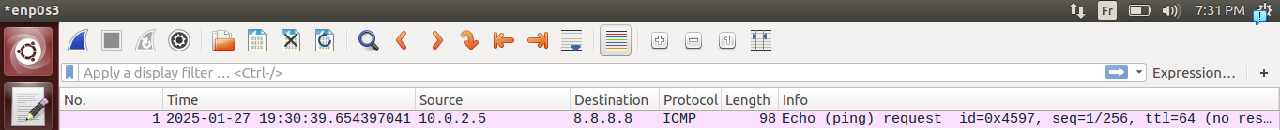
.we can see it clearly in wireshark
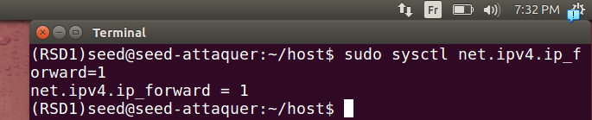
.if we activate the forwarding in attaquer machine so next pings goes to address direction
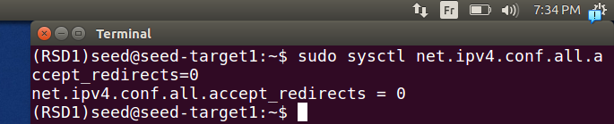
.in other hand we stop the acceptenss o redirection packets because it because if we don’t next time it will just reupdate it because our machine when activating forwarding it still will send redirection packets when ther’s a better path
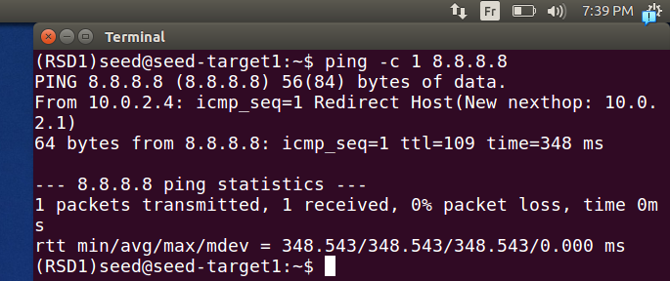
.here we ping and it’s with success because we received a packet.
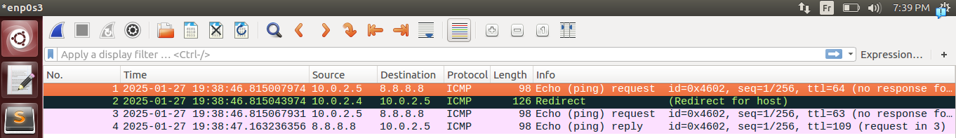
.and it can be see in the wireshark, and also the redirection packet we talked about earlier machine attaquer send it to inform the victim machine.

Question1:For a machine in outside LAN:
.
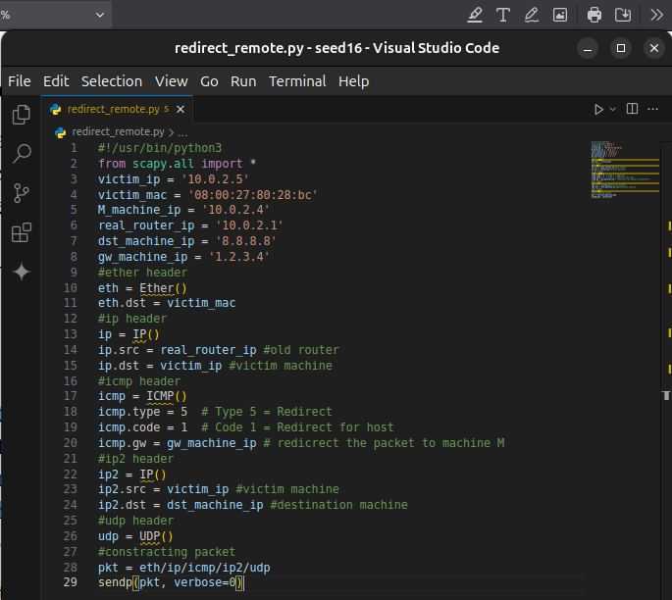
.we modify code first so the new gateway will be outside of our local network icmp.gw
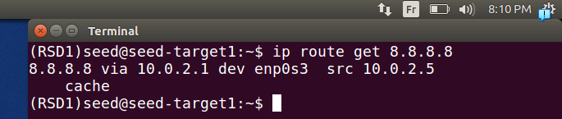
here we verify it first before changing it’s the default gateway as before
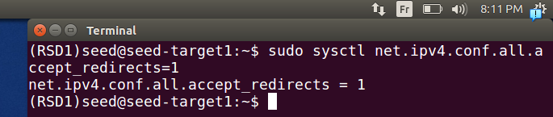
here we activate the redirection acceptness of icmp redirection so our attaque works
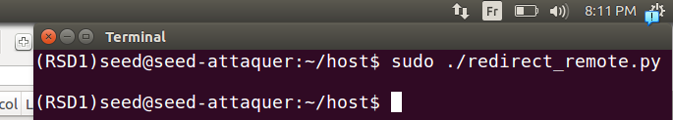
if we lunch our script from attquer machine
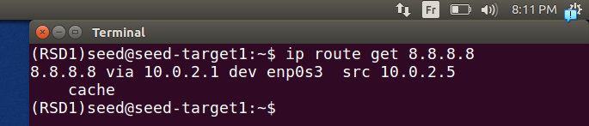
we can see that it didn’t work (it didn’t change)
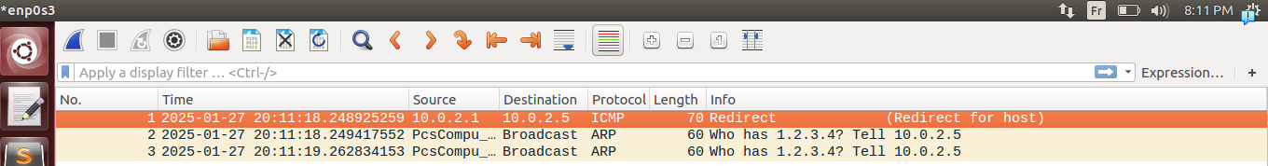
.here also we can see that the packet got to the machine victim but didn’t do anything, and you can see more that he’s asking about it’s mac address because he doesn’t have it in his arp cache table, that’s because icmp redirection is only for local network it’s used to tell a machine in a local network that this is not the best way to go to the destination you want to go to.

Question2:For a machine in LAN non existing:
.
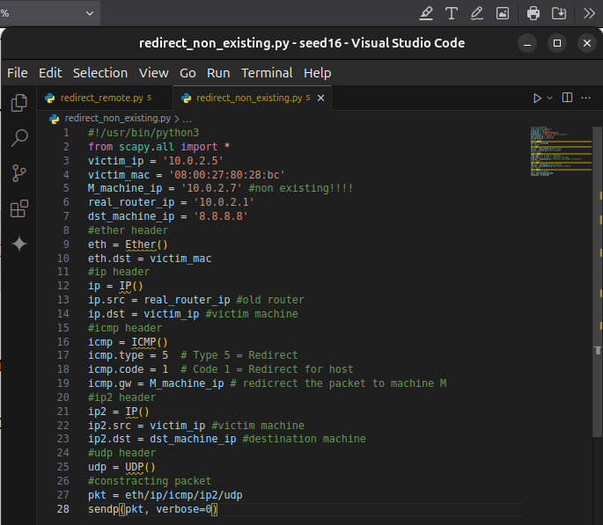
first we changed in the code the address of icmp.gw to an address non existing . Note that this address is not in our arp cache table
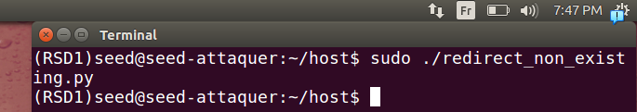
.here we lunch our script on the attaquer machine
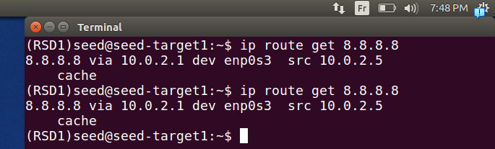
.here one command executed before and after it didn’t change, we failed.
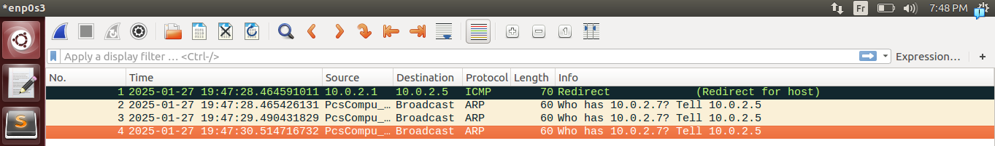
.as you see in wireshark our icmp redirection did get to the victim, but needs the mac address of that machine but it doesn’t exist, nobody response to it. So we decided to use technique or arp cache poisining.
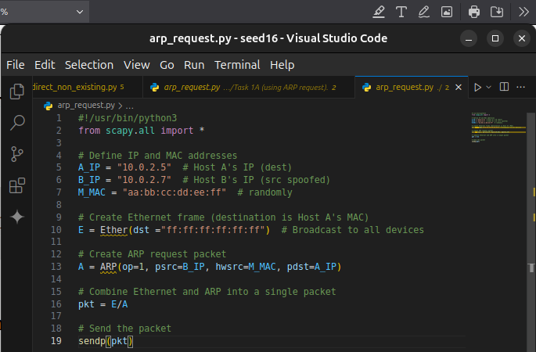
.here we use an arp request because it’s the only one that can add a new ip into arp cache table of the victim if ip doesn’t exist, and we give a random mac addresse to it
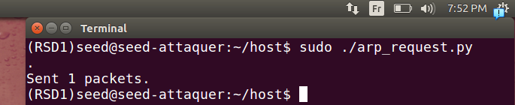
.here we lunch our script (arp request) from the attaquer machine.(to perform the arp cache poisining)
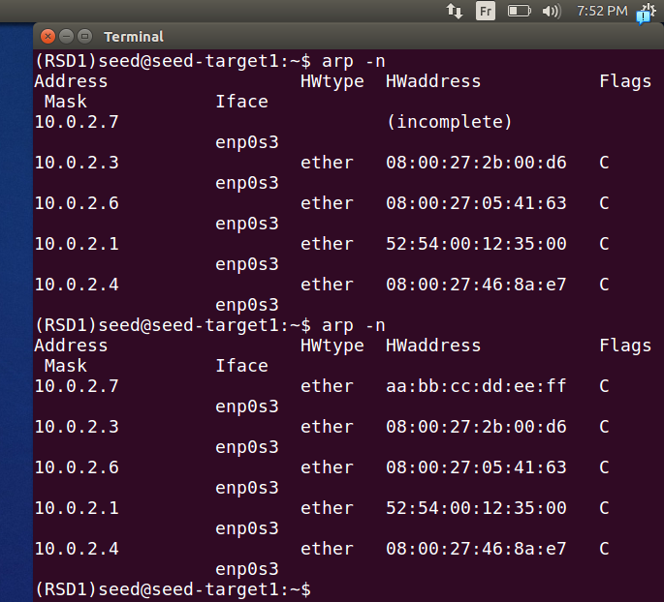
.here we can see old arp cache table before and after poisining, it changed succesufully
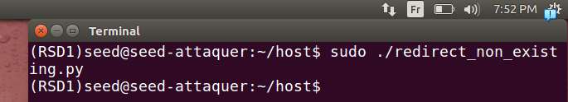
.here we can lunch our script(redirection) from attaquer machine
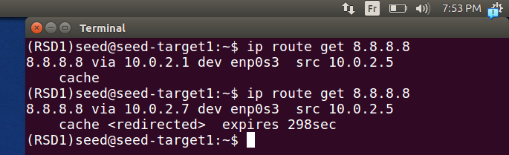
.here a command excuted before (it got default gatway), and after the script it’s succeffull
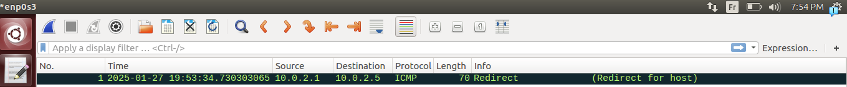
.we can see it in wireshark also

Task 3: Routing and Reverse Path Filtering

Task 3.a: Network Setup
.
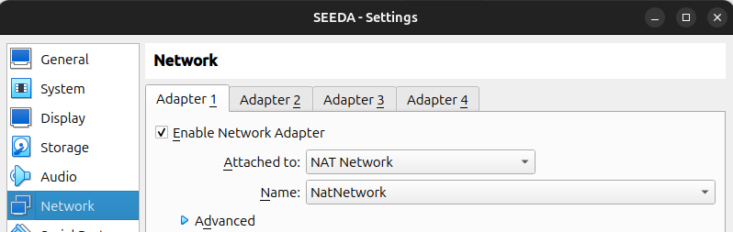
.here we set up the network for machine A attaquer it should be in (10.0.2.0/24)
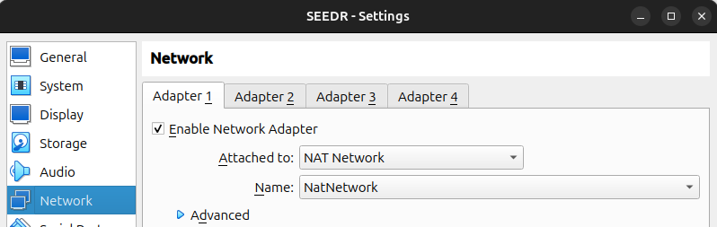
.here we set up the network for machine R that will play the role of a router it should be in (10.0.2.0/24)
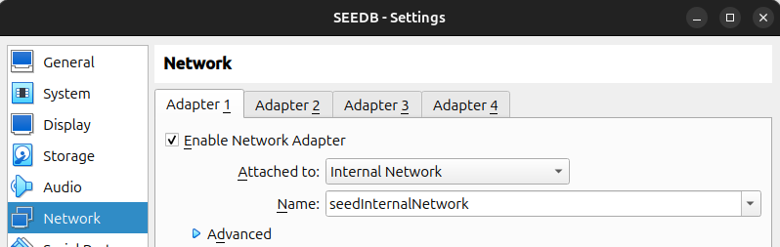
.here we set up the network for machine B victim it should be in (192.168.60.0/24)
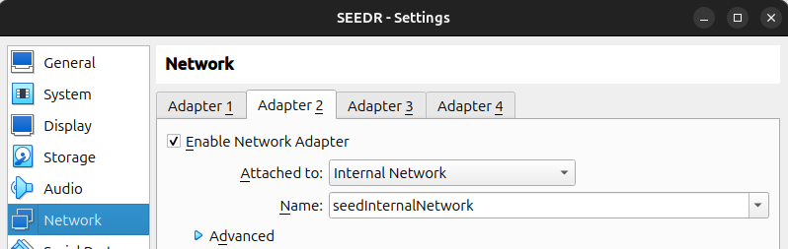
..here we set up the network for machine R (router) it should be in (192.168.60.0/24), this the second interface for it.
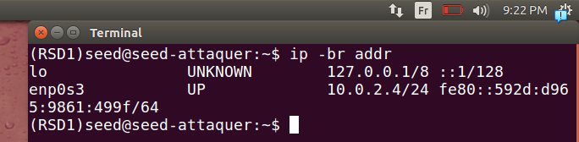
.we can see ip address already configured for machine A attaquer
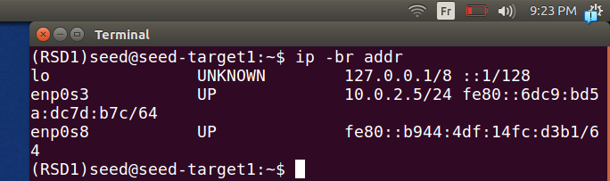
.same goes for the interface enp0s3 (related to machine A) it’s already configured because of DHCP in configuration of virtual box par default, but for the local network it’s still not configured (absence of dhcp => manually configuration)
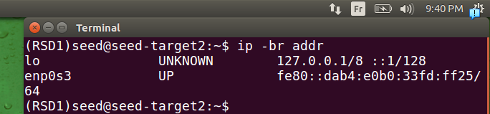
.here we see in machine B the victim that the address is not set yet also we will manually configure it .
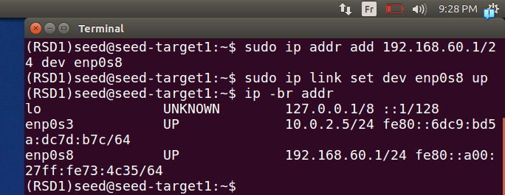
.we configure machine R (router) we set the ip to the interface statically
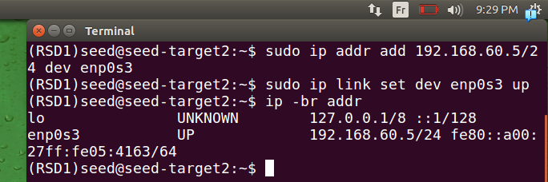
.same goes for machine B (victim)

Task 3.b: Routing Setup
.
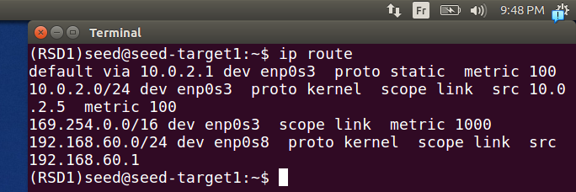
.here we show routes of the router machine R :
10.0.2.1 default gateway if address not listed in it
10.0.2.0/24 alow communication with devices in that network via 10.0.2.5
192.168.60.0/24 alow communication with devices in that network via 192.168.60.1
169.254.0.0/16 : used to when machine didn’t get ip address by default gateway, and it’s a non retable address, can be used only in local(system auto assign it)
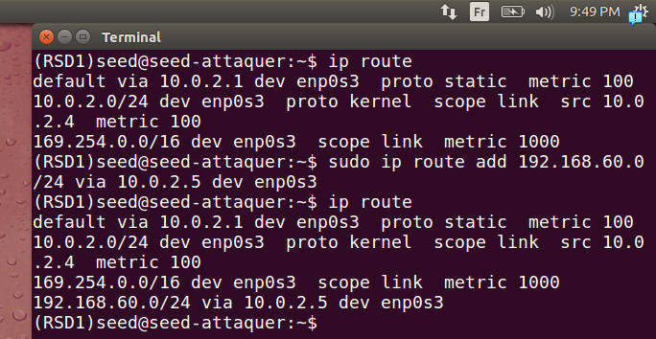
.here we add our network of machine B (local network)
it work fine

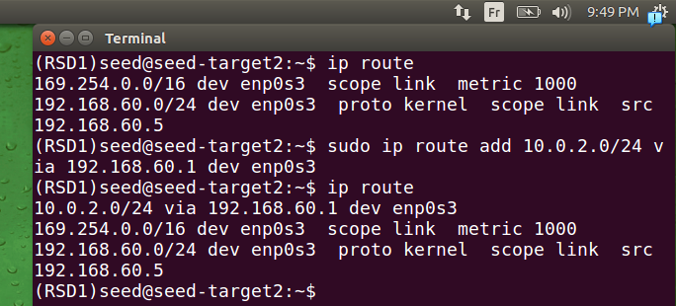
.same goes for machine B but we added A network.
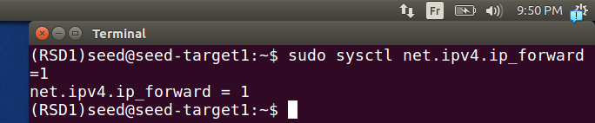
.we activate forwarding so packet when packets arrives route forward it (ping).
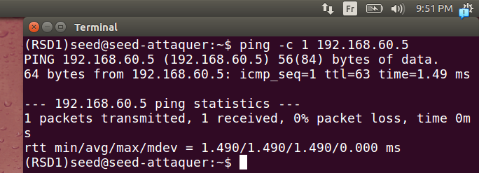
.if we tst on machine A to machine B
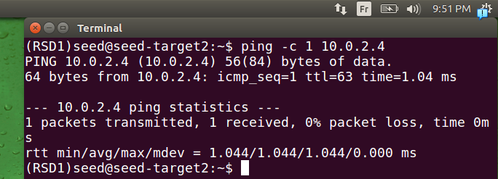
if we try same goes for machine B to machine A
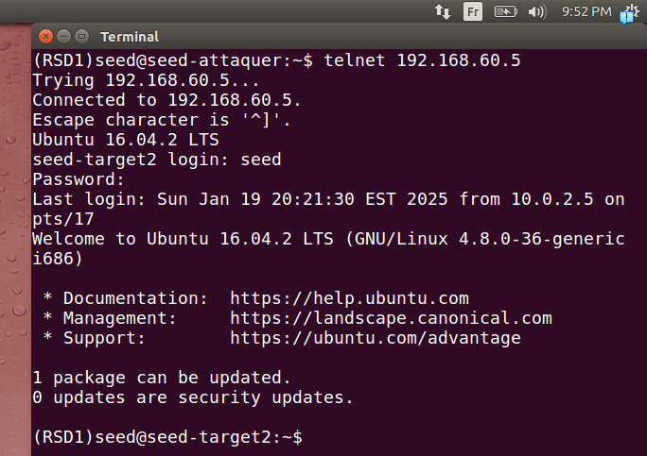
.if we telnet it also works fine.

Task 3.c: Reverse Path Filtering

.IP address belonging to the network 10.0.2.0/24
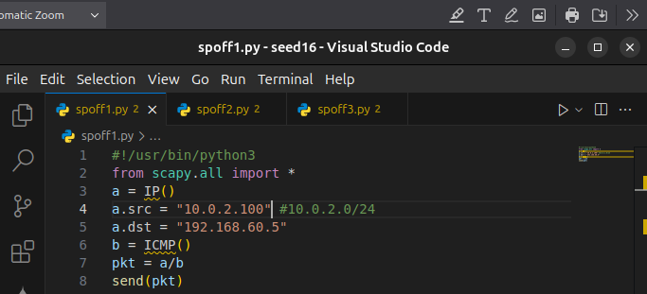
.here we create an ICMP request packet with source as mentioned (belonging to network specified)
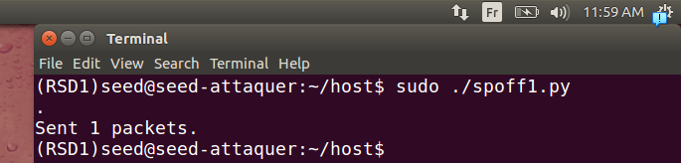
.here we lunch our script form attaquer machine
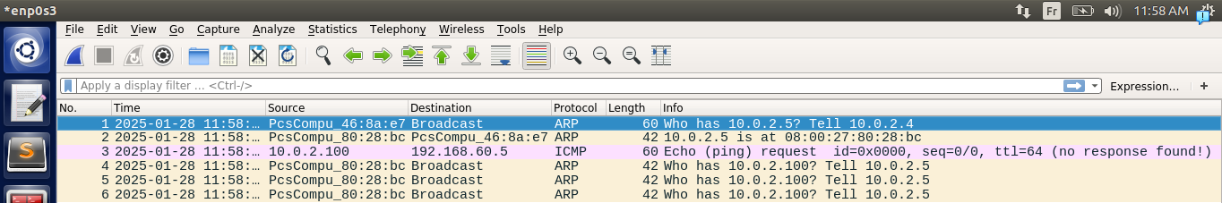
.we can see that it got to to the first interface after asking about mac address of router machine(it’s interface we talk about). Those later packet Who has 10.0.2.100 (comes because the reply we got it so he’s asking about mac address to send the reply)
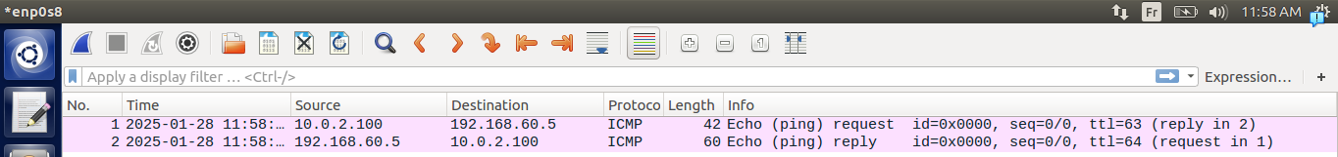
.in the interface that’s related to network local network we can see the request and the reply, it’s working
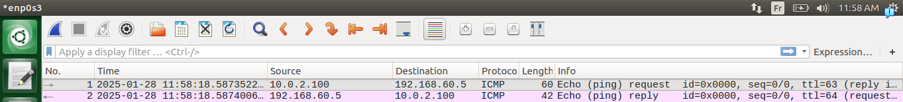
.here we can see the request and the response it’s redundent to the last one but just for viewing pupose

IP address belonging to the internal network 192.168.60.0/24.
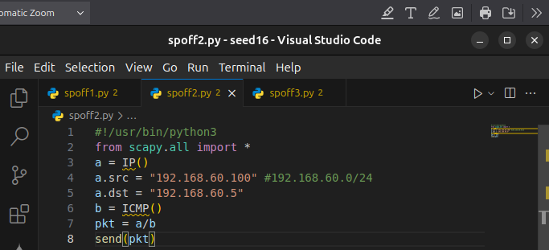
.here we modify again the source
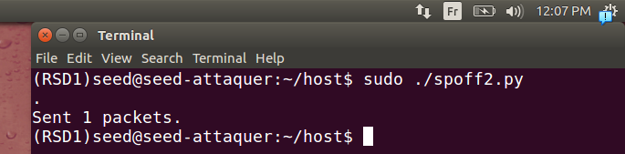
.we lunch the script from attaquer machine
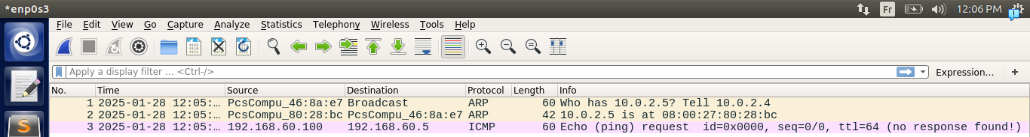
.here the request is got into the router like last time, with arp message like last time
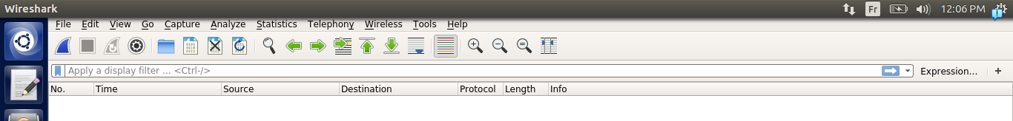
.no request here because RPF (will be explained breifly at the end) need like specific interface you came from has the same subnet as the ip you sent you were from.
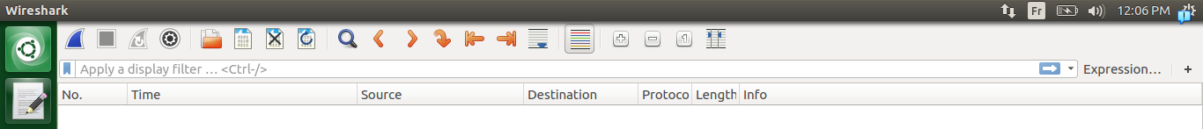
.same here (it’s redundent) note that this approche is helps in stopping spoofed messages.

IP address belonging to the Internet, such as 1.2.3.4
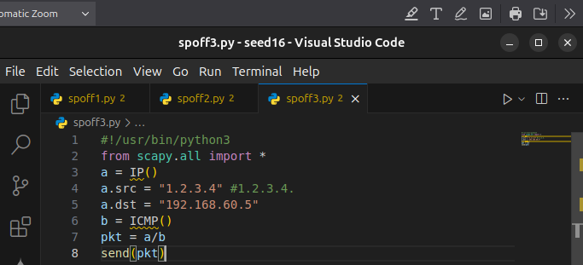
.here we modify it again the src so it belongs as mentionned.
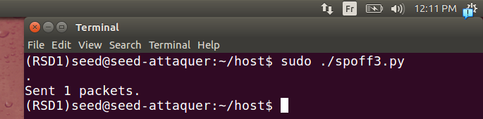
.we lunch again the script modified
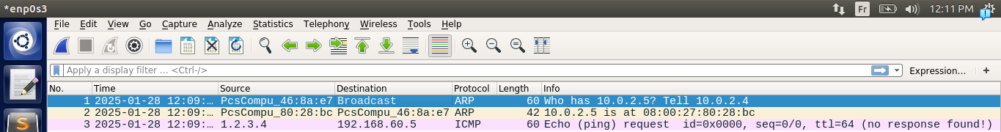
.here we can see that it arrives succefully to interface of router connected to attaquer machine, and before it mac resolver like last time(arp request)
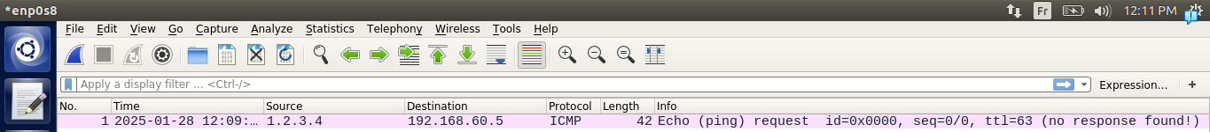
.here in the interface of R machine connected to the victim we can see that we have only, a request no respond the reason is explained last image
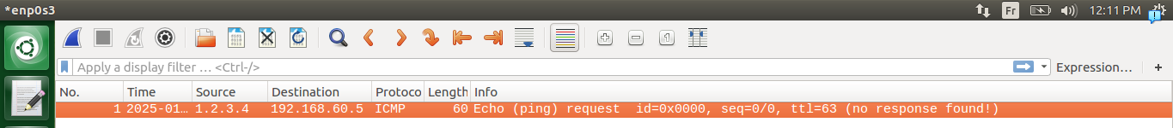
.here we can see it as mentioned before we can say that it’s redundent
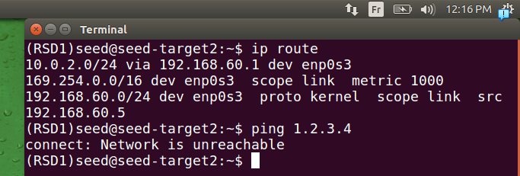
.here as you see we don’t have a route that can get us to 1.2.3.4 we can confirm that with a ping 1.2.3.4 to resolve that we can make a route specified for it, or make a default gatway.

Breif Explaination of how it works Routing and Reverse Path Filtering:
In routing we use routing table to decide outgoing interface for packets based of destination ip and also from the more specific to the more general but that routing has another gain it’s used by RPF(Reverse Path Forwarding) to spot spoffed packets so they take ip src and see if it can exit if it can we let it enter and it’s called symetric routing, if it’s not it’s called asymmetric and it’s dropped.

